PATHSHALA NEPAL FOUNDATION

PRE-UNI PROGRAM

Baneshwor, Kathmandu



Lab assessment report on

Web Technology III (PHP)

**Submitted By:** **Submitted To**

Name: Raunak Raj Adhikari Department of Computer Science

Class: 12 PATHSHALA NEPAL FOUNDATION

Group: 2

Date: 2024-03-19

2. Explain different types of operators used in PHP with example.

3. Explain Control Structures available in PHP with suitable example.

4. How do you declare variable in PHP? Discuss briefly about the scope of variable such as local, global and static with the suitable example references.

5. Define Array. Explain beriefly about Associative Array and Indexed array with suitable examples.

6. Write down the steps to connect PHP with MySQL database server with example

7. Write PHP program to.

1. To display certain messages like “PATHSHALA PRE-UNI PROGRAM, PNF” along with its localtion and goal using PHP.

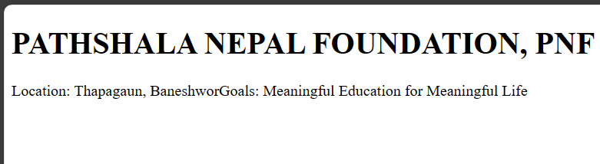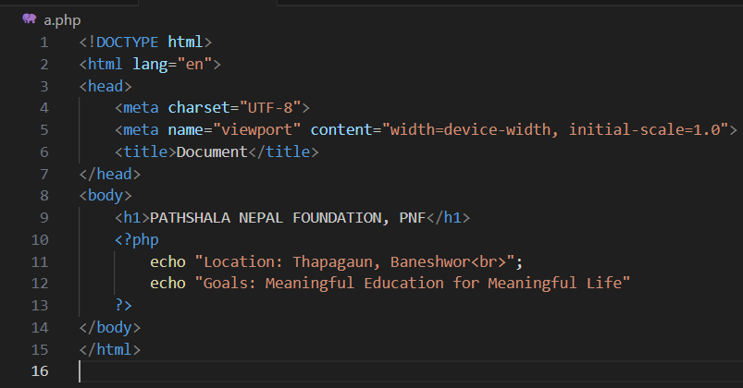

1. To calculate the sum, difference, product, quotient and remainder of any two integers input by a user.

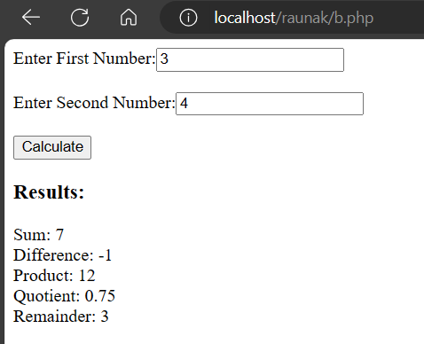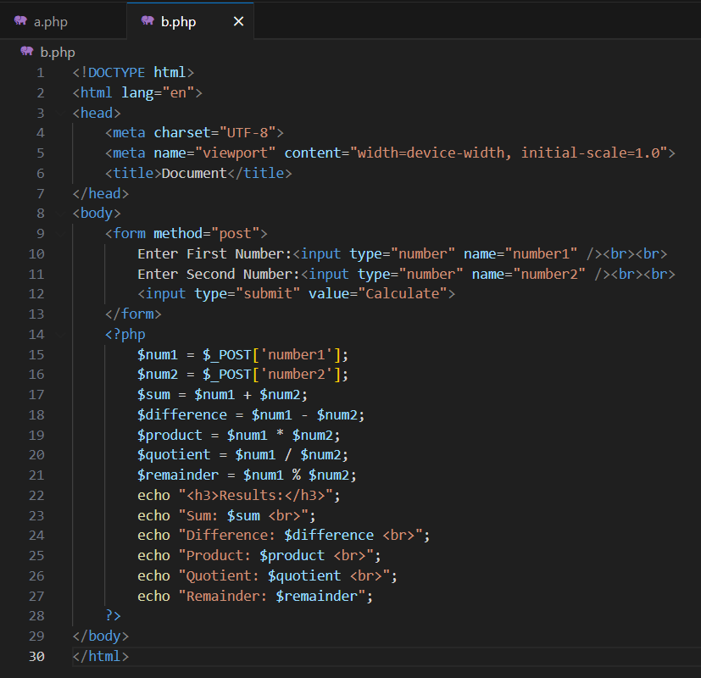

1. To find the greatest and smallest values among three numbers input by a user.

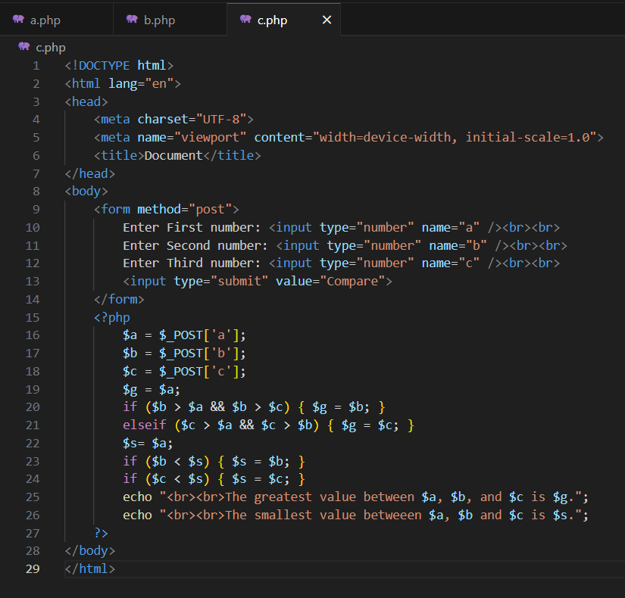

1. To calculate the simple interest for the supplied principle, rate of inerest and time period by auser by using a suitable user-defined function using PHP.

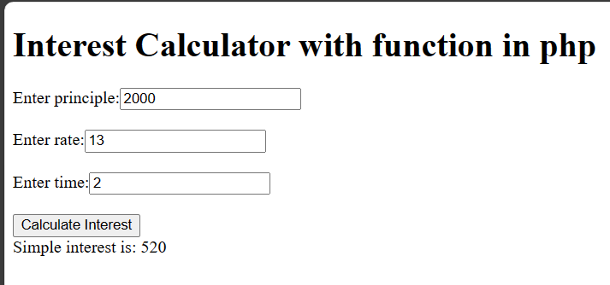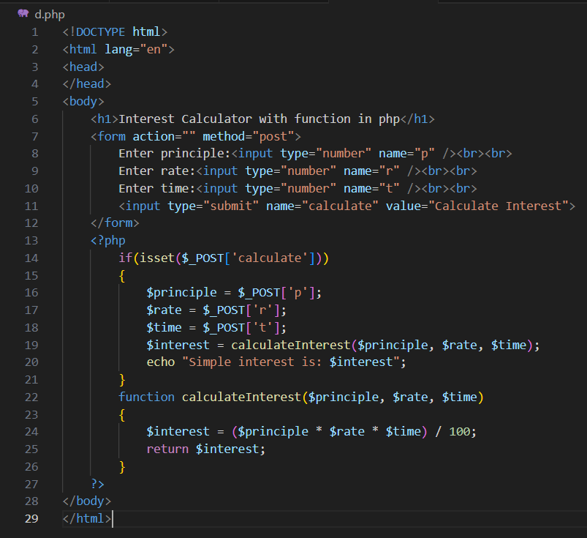

1. To display multiplication table for a constant ineteger (say 5).

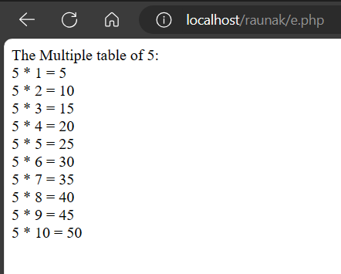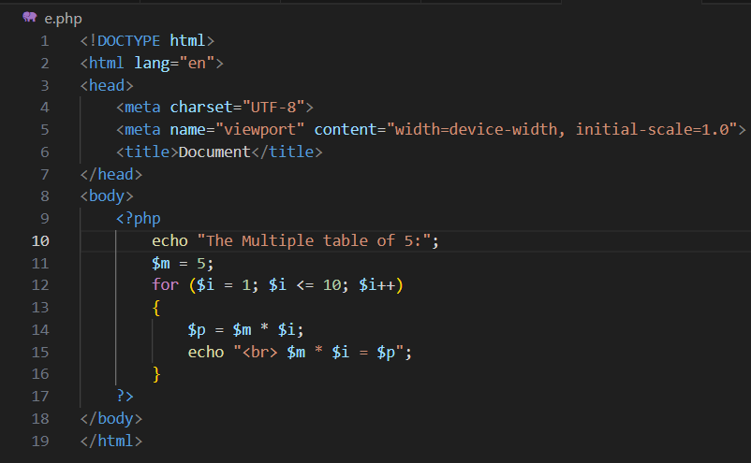

1. To display multiplication table of an integer input by a user.

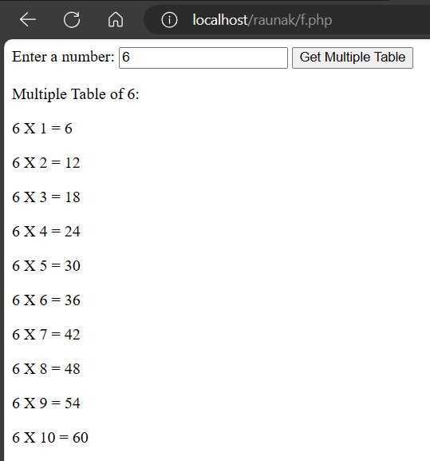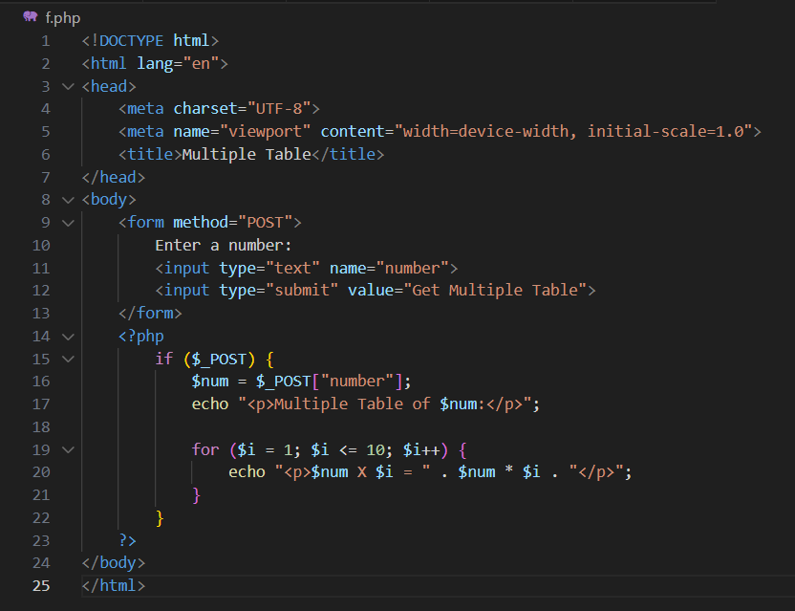

1. To display the multiplication table of 1 to 10 with 10 multiples of each.

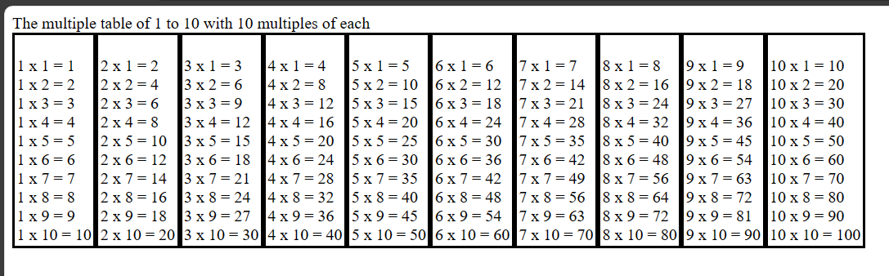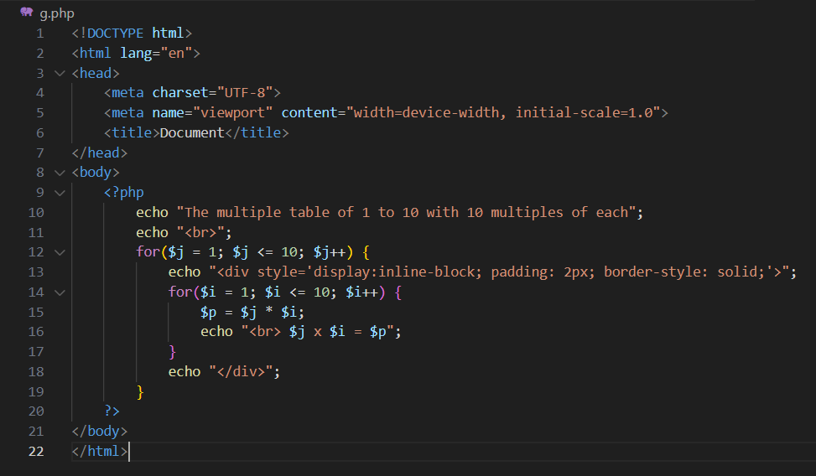

1. To calculate factorial value of a positive integer input by a user by using a user-defined function named fact().

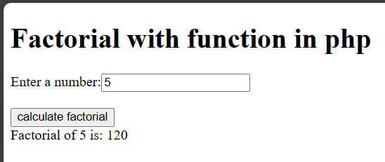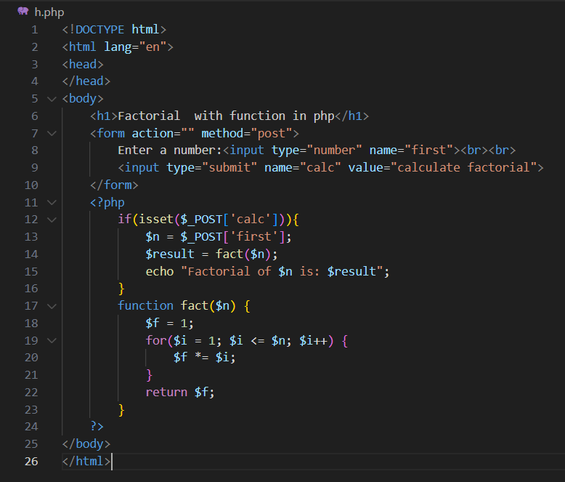

1. To ask a user for inputting an integer (day in number) and display the proper day using switch-case-default strucutre [e.g. if the input number is 1 then the output should be “Sunday”]

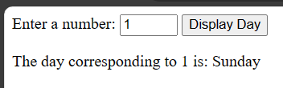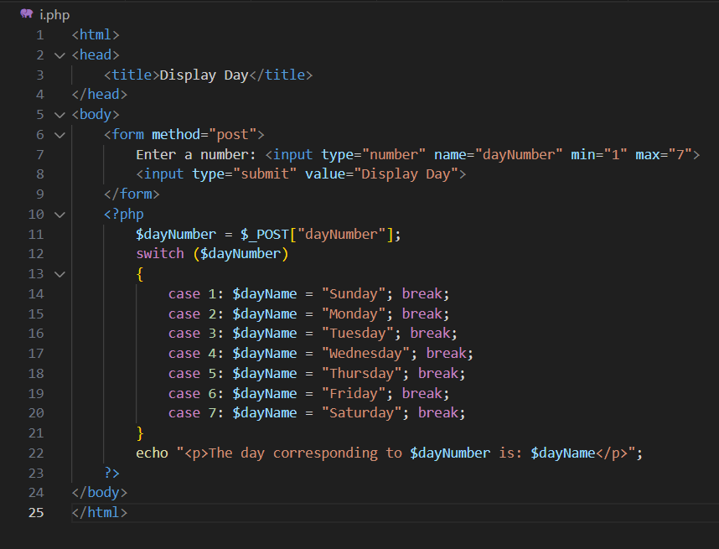

1. Demonstrate the use of Indexed array and Associative Array.

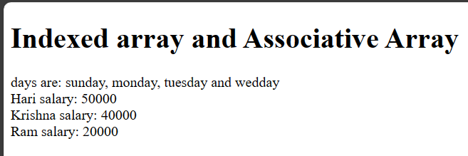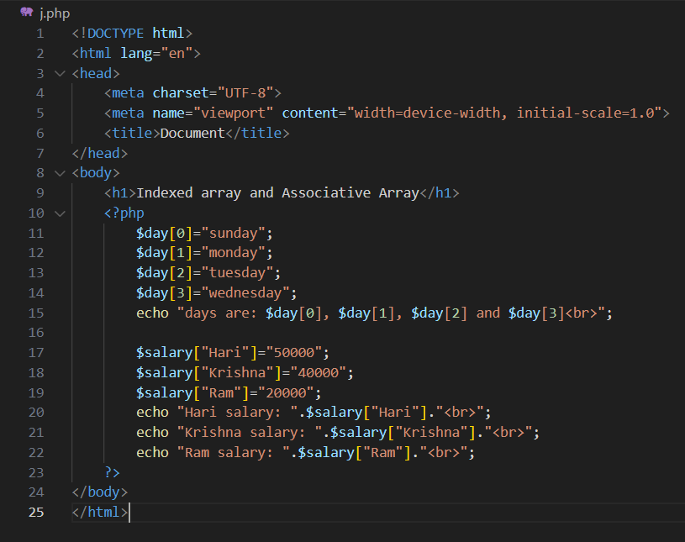

1. Input User Detail (id, name, email, password) using form and display to other page.

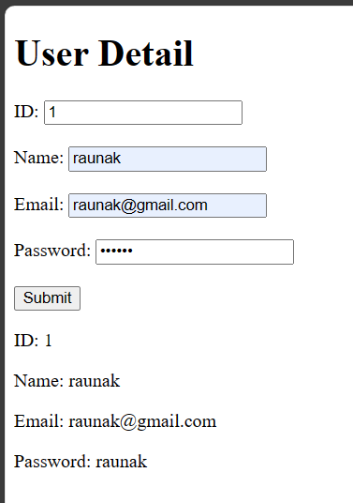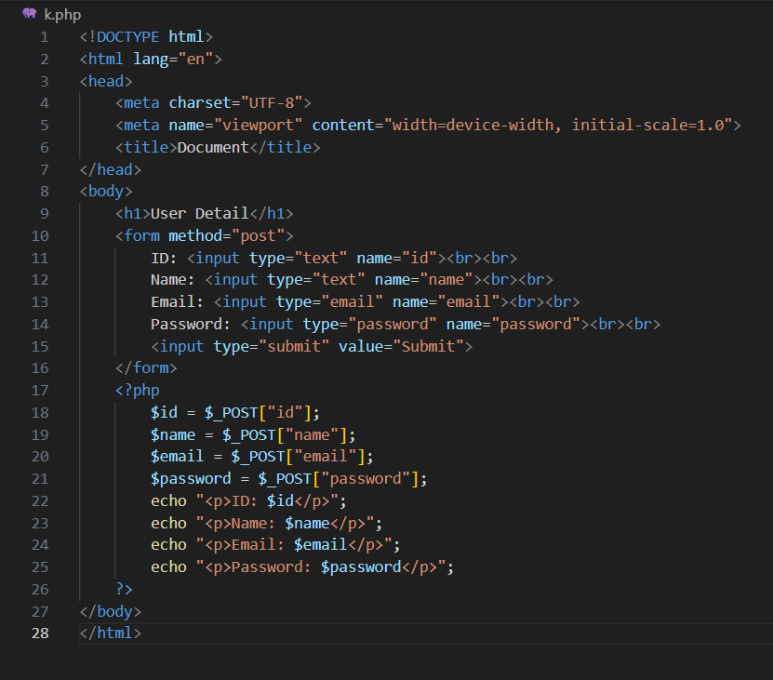

1. Create a database named personal_info using PHP and MySQL.

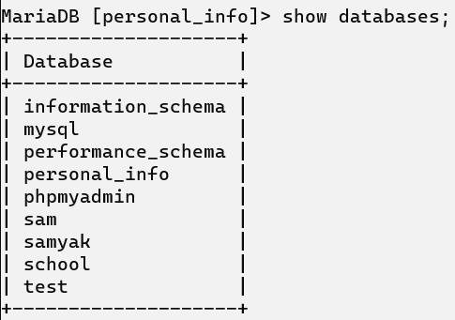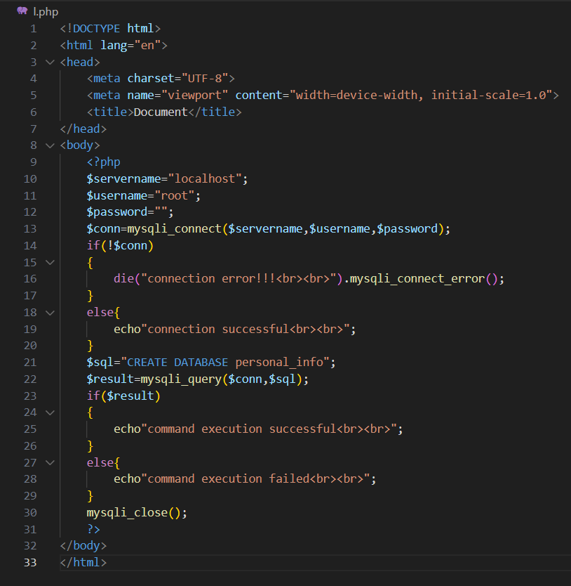

1. Create a table user(id, name, email, password) in the above database using PHP.

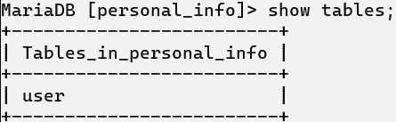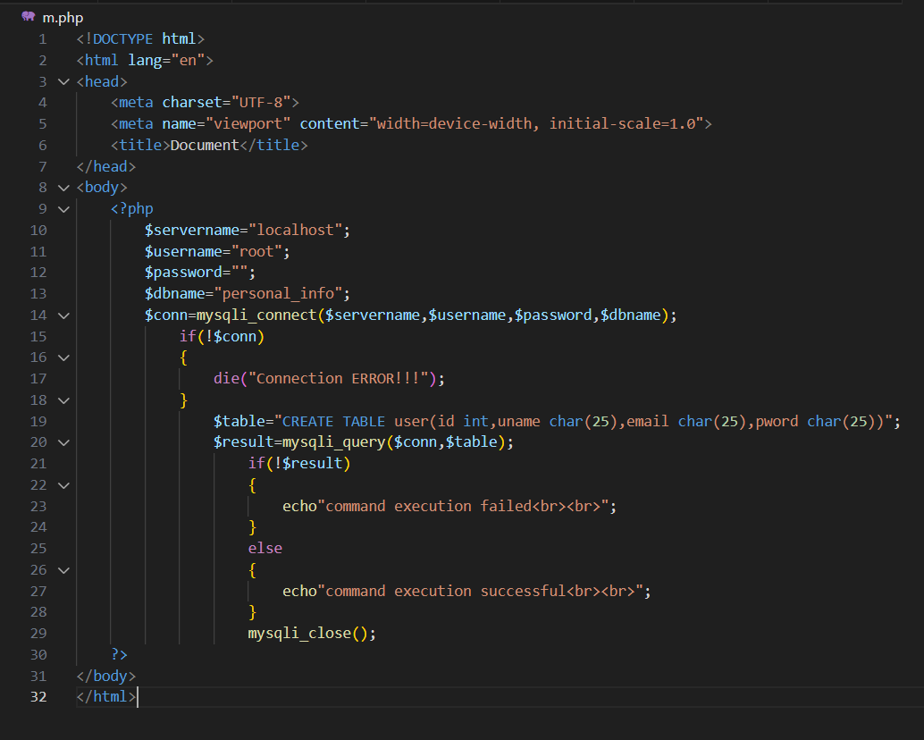

1. Insert any five records in a table user with fields id, name, email, password using PHP.

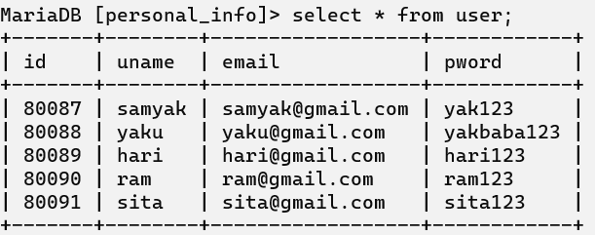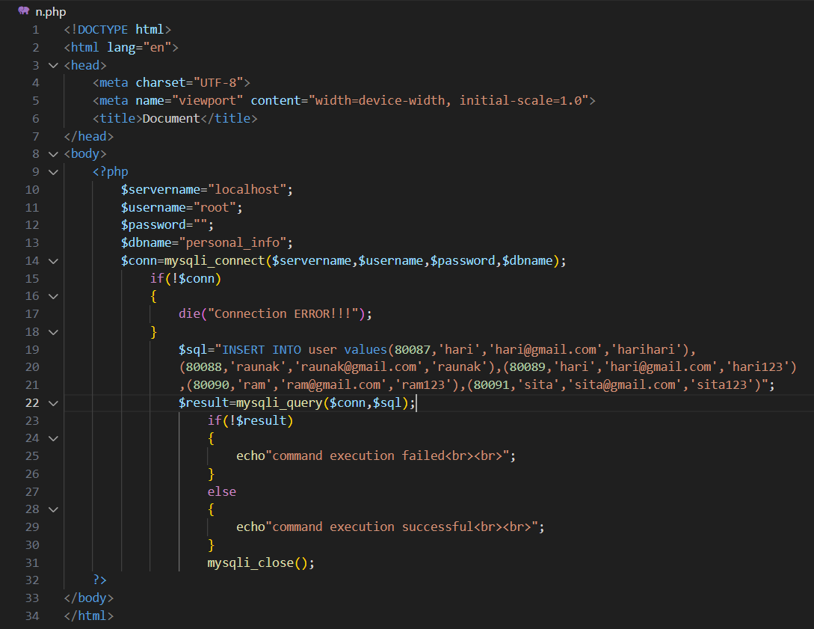

1. Create a form with id, name, email and password to ask a user for data supply and add it to user table of personal_info using PHP.

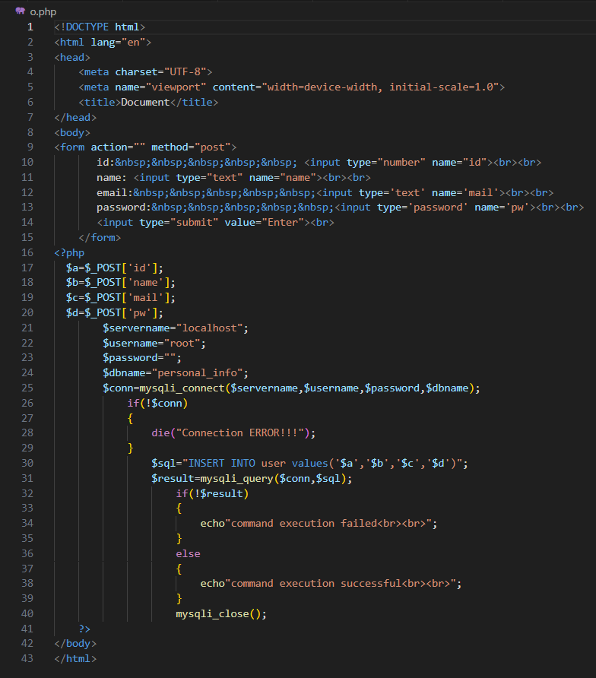

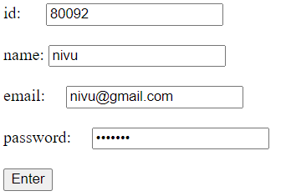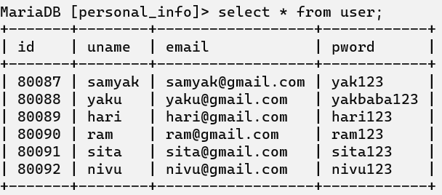

1. Display Users records by retriving data from user table using PHP.

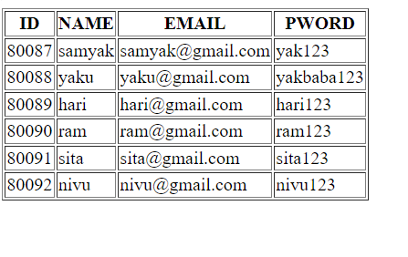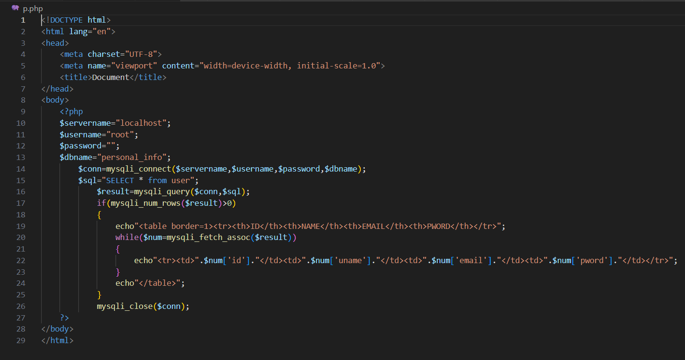

1. Update email to “hari.khadka@gmail.com” whose email is “hari@gmail.com ” using PHP.

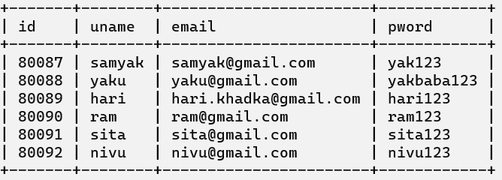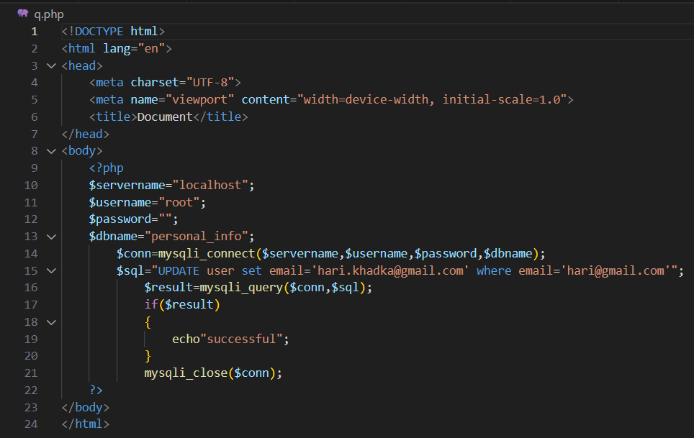

1. Delete user record whose email is “ram@gmail.com” using PHP.

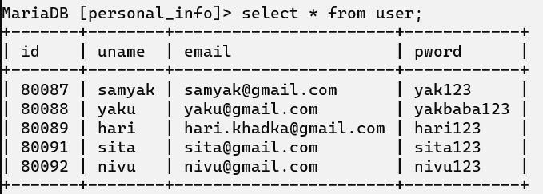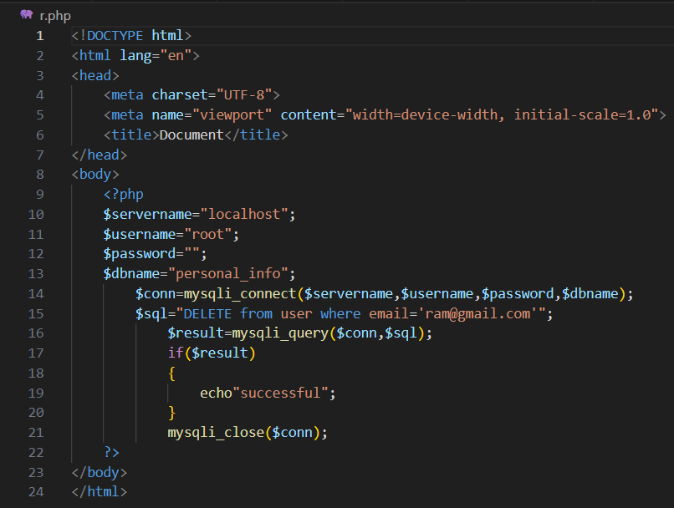

1. 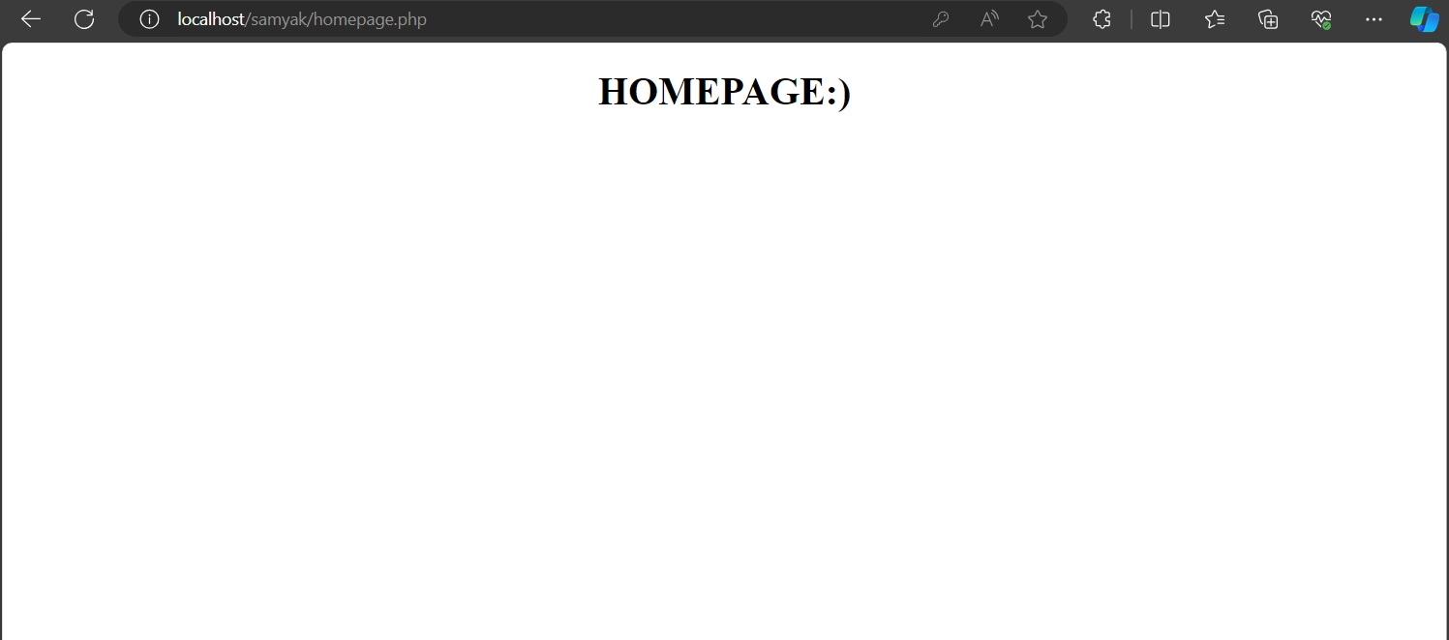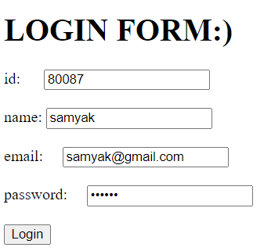Create a logn form to verify the record with reference to database (personal_info) if successful, move to home page otherwise display an error message. 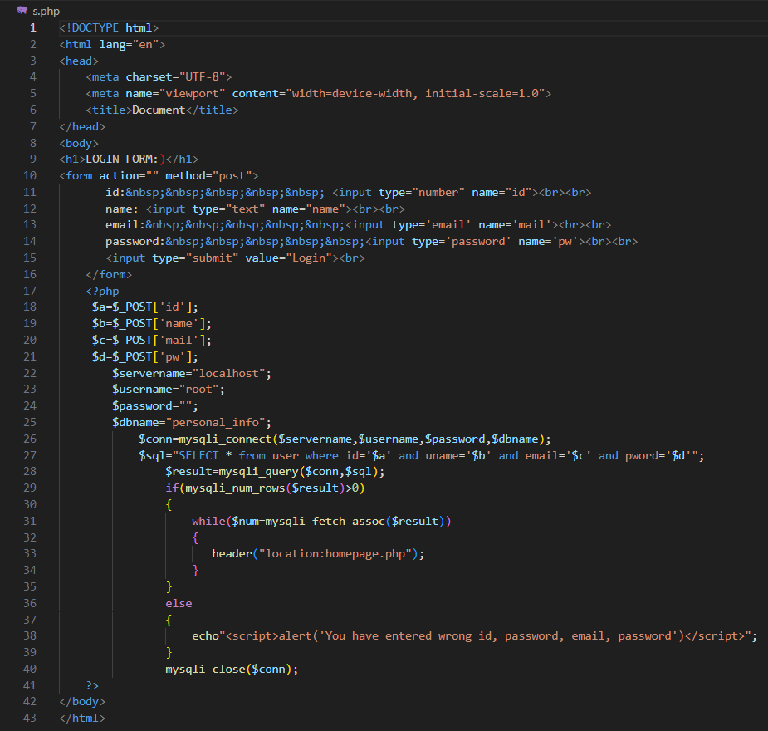

**Conclusion**

I would like to thank Mr.Suresh Sir for teaching us many things as for our better future. I have come to learn a lot from this project. This opportunity has given me indepth knowledge about PHP

Thank you.